**Family Support**

**Lady Manners School – Primary Cluster**

Dear All, I hope you are all still keeping well and safe. Please read on for more resources, ideas and sources of support. Remember, asking for help and reaching out is a sign of strength so please do so if you need to, even if it’s a virtual cuppa with a friend.

If you have found anything that has been really helpful for you or a great family activity, do please share and I will include in future communications.



Many of us are finding that routines are changing again with some schools and workplaces returning, the chance to see more friends and family at social distance and more shops and services reopening. As much as this can be a positive thing, a change of routine and how these changes are perceived mean that it is important to notice and acknowledge ours, and our Childrens thoughts, feelings and behaviours around this.

Be kind to yourselves and if you can, give time to each other to offer a listening ear and support.



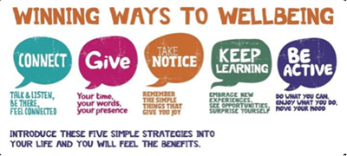<https://www.nhs.uk/conditions/stress-anxiety-depression/improve-mental-wellbeing/>

This time … **Give**

Small acts of giving and kindness can be huge to the person that is receiving it, particularly at the moment when change and isolation may be affecting us.

It can also have a positive impact on the giver’s wellbeing through:

* Creating positive feeling and a sense of reward
* Giving you a feeling of purpose and self-worth
* Helping you connect with other people

- **“Give”** – be creative with what this word can mean, it isn’t just about buying something and giving a present, you can give your time, your support, your smile, your understanding and comfort.

- **Saying “thank you”** – being grateful to someone else for something they have done is a way of giving back, how can you thank someone that has helped you?

- **Volunteer** – opportunities may not be as apparent at the moment but there’s always someone that may need some help and support, this could be through phone calls to someone that is isolated, collecting shopping for a friend or neighbour or helping with the local food bank.

* **Small acts of kindness** – Doing something for someone that they don’t expect or ask for is a great way of showing you care or are thinking of someone, this could be surprising them with a gift or card you have made, helping with a task they haven’t finished yet, making them a cup of tea, baking.





**Something to try:**

**Set a challenge and do a scavenger hunt**

from: @weareteachers

**Try making a Rainbow collage to give as**

**a gift**

**Add a secret message with invisible ink!**

[](https://www.facebook.com/WeAreTeachers/photos/a.10150774463388708/10158582623583708/?type=3&theater&ifg=1)



[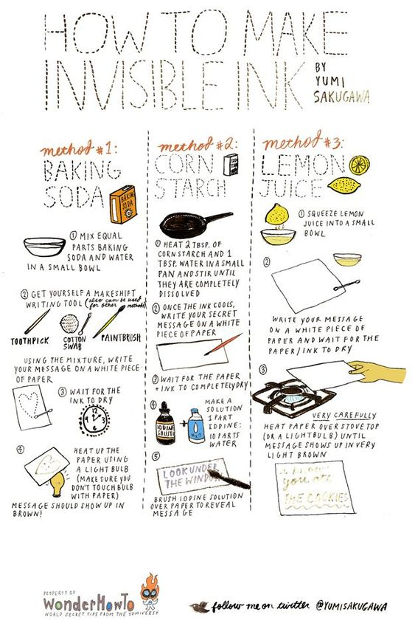](https://bitrebels.com/wp-content/uploads/2012/02/How-To-Invisible-Ink-Infographic.jpg)



[](https://www.facebook.com/learningdoingandbeingwell/?eid=ARBBOvvO6BxHm6Cyj8Npb3FWrEr1Mp3aHVMIh4cNkXfDS68-NLy1mfyddB2tHoFKrrsE7oCYe-f_tAIR)

**Jo from “Well within Reach” has joined us again to**

**share some tips and reminders to support you as**

**parents**

**Top tip if you're feeling like you just haven't got the resources, time & energy to do it all!**

"The idea that any of us can work, parent & teach; not to mention all the other jobs that need to be kept on top of; is based on no more than a wish. What's more, this isn't our wish! If we don't accept that our best is good enough we end up on the never ending treadmill of 'I will be satisfied once...' and never reaching it.

We also end up too tired or irritable to enjoy our kids, or can't be fully present with them during the 'free' time that we have with them because our mind is somewhere else. It's not an easy switch to make, but even if you take a few minutes of the day, bring your attention to what you have done, not just what you haven't. Measure the time that you spend with your kids not by the quantity but by the quality.

Everyone benefits much more if you can be fully present & connected with your kids for short bursts throughout the day, instead of trying to be everything to everyone all the time, and only able to do any of it halfway. It's also helpful to start the day with a 'permission'. What's can you let yourself off the hook for, what really doesn't need to be done today, what can wait, what can you accept as 'enough'.

If you can't change something, the first step to not allowing it to affect our wellbeing is acceptance".

This tip was taken from Jo’s FREE PDF “5 Daily Ways for Emotionally

Healthy Brains” which you can access through Jo’s FB group

**“Parent with insight Collective**

Find Jo on **Facebook** [@learningdoingandbeingwell](https://www.facebook.com/learningdoingandbeingwell/?eid=ARBBOvvO6BxHm6Cyj8Npb3FWrEr1Mp3aHVMIh4cNkXfDS68-NLy1mfyddB2tHoFKrrsE7oCYe-f_tAIR)

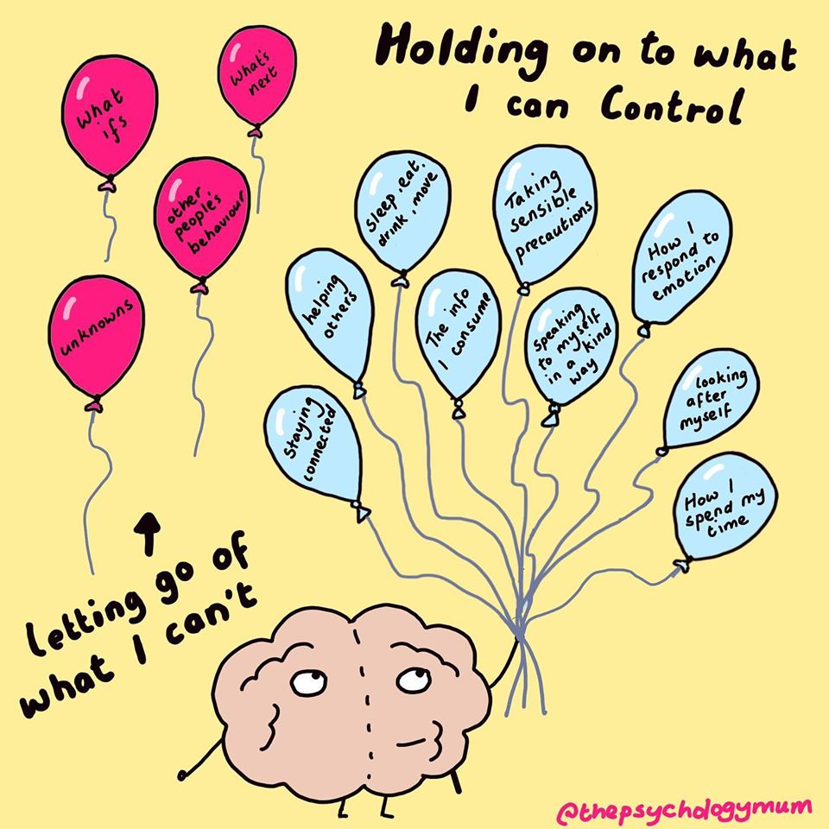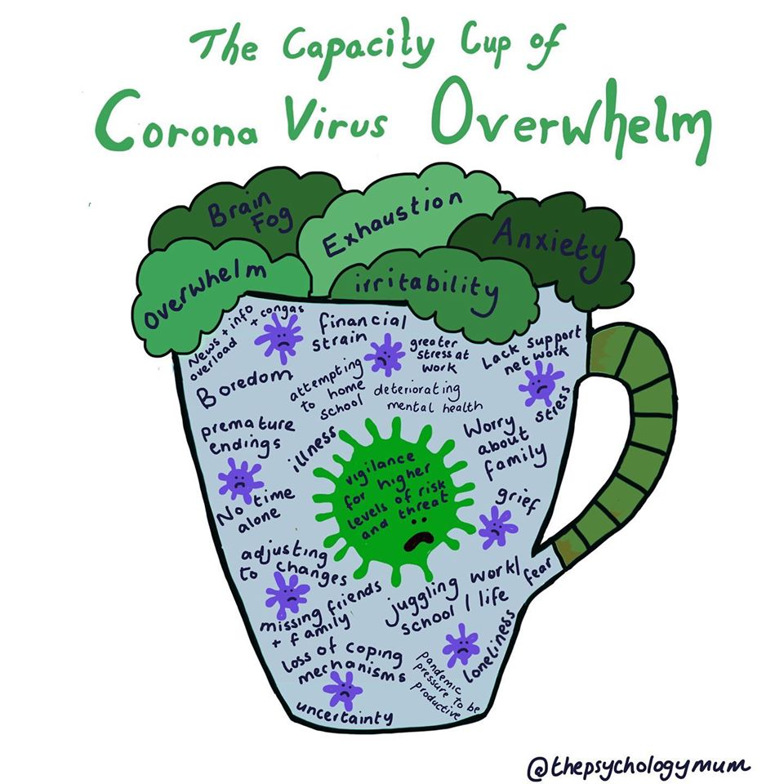Hi again Amy, Thanks for bearing with me. These are big topics and all very normal so here's my initial response to each one and there will be more to follow. Top tip if you're feeling like you just haven't got the resources, time & energy to do it all! "The idea that any of us can work, parent & teach; not to mention all the other jobs that need to be kept on top of; is based on no more than a wish. What's more, this isn't our wish! If we don't accept that our best is good enough we end up on the never ending treadmill of 'I will be satisfied once...' and never reaching it. We also end up too tired or irritable to enjoy our kids, or can't be fully present with them during the 'free' time that we have with them because our mind is somewhere else. It's not an easy switch to make, but even if you take a few minutes of the day, bring your attention to what you have done, not just what you haven't. Measure the time that you spend with your kids not by the quantity but by the quality. Everyone benefits much more if you can be fully present & connected with your kids for short bursts throughout the day, instead of trying to be everything to everyone all the time, and only able to do any of it halfway. It's also helpful to start the day with a 'permission'. What's can you let yourself off the hook for, what really doesn't need to be done today, what can wait, what can you accept as 'enough'. If you can't change something, the first step to not allowing it to affect our wellbeing is acceptance". Top tip for supporting transitions "It's perfectly normal that parents & children alike are worried about transitions back to school and what that will look like. We don;t want our kids to be anxious so often our 'go to' response is 'don;t worry'. Although I'm not suggesting, of course, that you tell your children to worry, 'don't worry' doesn't tend to be very helpful on its own either. Don't be afraid of exploring these conversations with your kids; it won't make them worry even more, What it will do is teach them that you take their concerns seriously, but that you're not afraid of them; this can help make a child feel much more, not less, secure. It's really important right now to give the message to our children that they can feel whatever they feel; we don't always have to automatically move into 'problem-solving mode'. Ask them questions, help come up with solutions together, and make sure that your child has a plan ready for whatever they're worried about. It may just not be realistic to take the worry away, but at they're likely to worry a lot less if they at least know how to respond to it." Hope this is enough to be getting on with. Let me know if you need any more info and if you can continue to include the links to Well Within Reach and my FB group, that would be much appreciated. Thanks and let me know what else you need in due course,



[](https://www.facebook.com/learningdoingandbeingwell/?eid=ARBBOvvO6BxHm6Cyj8Npb3FWrEr1Mp3aHVMIh4cNkXfDS68-NLy1mfyddB2tHoFKrrsE7oCYe-f_tAIR)

**Top tip for supporting transitions**

"It's perfectly normal that parents & children alike are worried about transitions back to school and what that will look like. We don’t want our kids to be anxious so often our 'go to' response is 'don’t worry'.

Although I'm not suggesting, of course, that you tell your children to worry, 'don't worry' doesn't tend to be very helpful on its own either. Don't be afraid of exploring these conversations with your kids; it won't make them worry even more, what it will do is teach them that you take their concerns seriously, but that you're not afraid of them; this can help make a child feel much more, not less, secure.

It's really important right now to give the message to our children that they can feel whatever they feel; we don't always have to automatically move into 'problem-solving mode'. Ask them questions, help come up with solutions together, and make sure that your child has a plan ready for whatever they're worried about.

It may just not be realistic to take the worry away, but at they're likely to worry a lot less if they at least know how to respond to it.

Jo has a FB group called **“Parent with insight Collective”** which you can join to access more tips, advice, community and free workshops.

Find Jo at Well within Reach on **Facebook** [@learningdoingandbeingwell](https://www.facebook.com/learningdoingandbeingwell/?eid=ARBBOvvO6BxHm6Cyj8Npb3FWrEr1Mp3aHVMIh4cNkXfDS68-NLy1mfyddB2tHoFKrrsE7oCYe-f_tAIR)



[](https://www.facebook.com/groups/576075072829327/)

[](https://www.facebook.com/learningdoingandbeingwell/?eid=ARBBOvvO6BxHm6Cyj8Npb3FWrEr1Mp3aHVMIh4cNkXfDS68-NLy1mfyddB2tHoFKrrsE7oCYe-f_tAIR)



[](https://www.familylives.org.uk/)

**Useful Resources:**

**Family Lives**

Advice on all aspects of parenting, including dealing with bullying.

Phone 08088002222 (Monday to Friday 9am-9pm, Sat and Sun 10am-3pm)

[www.familylives.org.uk](http://www.familylives.org.uk)

**SANE**

Emotional Support, information and guidance for people affected by mental illness, their families and carers. SANELine 030030470000 (daily 4:30pm- 20:30pm) Textcare [www.sane.org.uk/textcare](http://www.sane.org.uk/textcare) [www.sane.org.uk/support](http://www.sane.org.uk/support)

**Samaritans**

Confidential support for people experiencing feelings of distress or despair.

Phone 116 123 (free 24-hr helpline) [www.samaritans.org.uk](http://www.samaritans.org.uk)

[](http://www.sane.org.uk/support)



